# **How To Create VPC and Bastion Host on AWS**

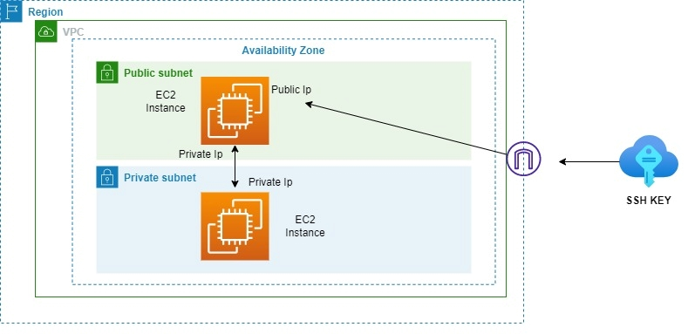

## **Virtual Private Cloud**

A

mazon VPC lets you provision a logically isolated section of the Amazon Web Services (AWS) cloud where you can launch AWS resources in a virtual network that you define. You have complete control over your virtual networking environment, including a selection of your own IP address ranges, creation of subnets, and configuration of route tables and network gateways.

* Login in to AWS. Go to [https://console.aws.amazon.com](https://console.aws.amazon.com/).
* Click on VPC under Networking
* Click on “Create VPC”.
* Choose VPC only

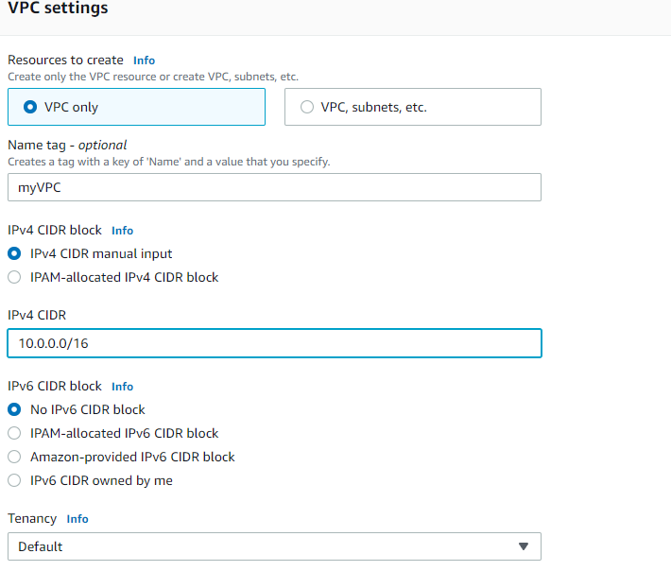

* Edit DNS hostnames-Enable

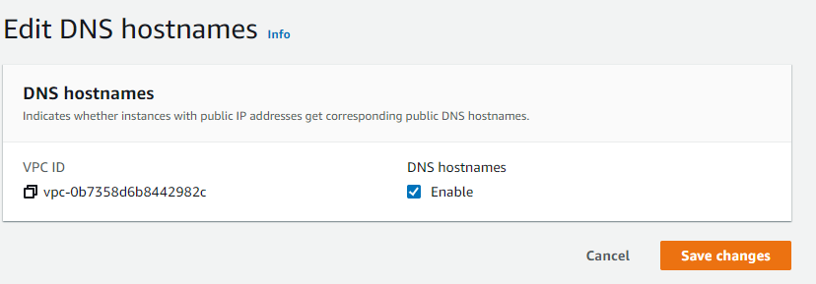

* Under myVPC create Public Subnet

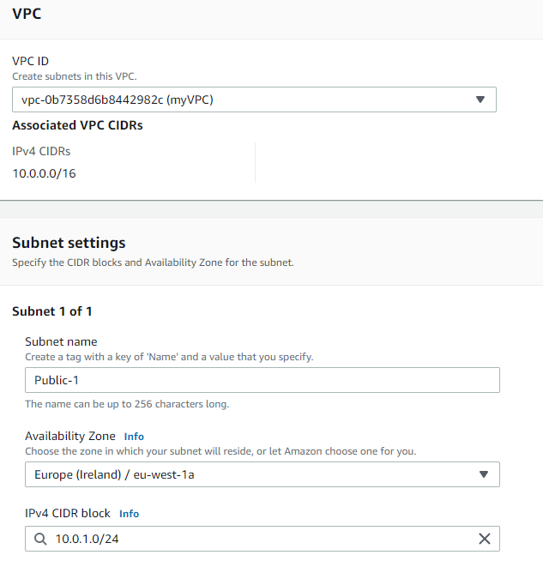

* Edit Public-1 Subnet settings
  + enable auto-assign public IPv4 address

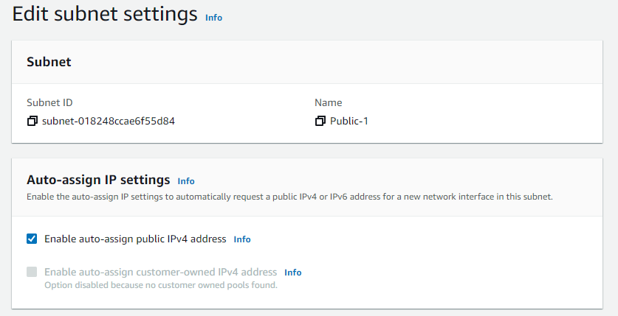

* Under myVPC create Private Subnet

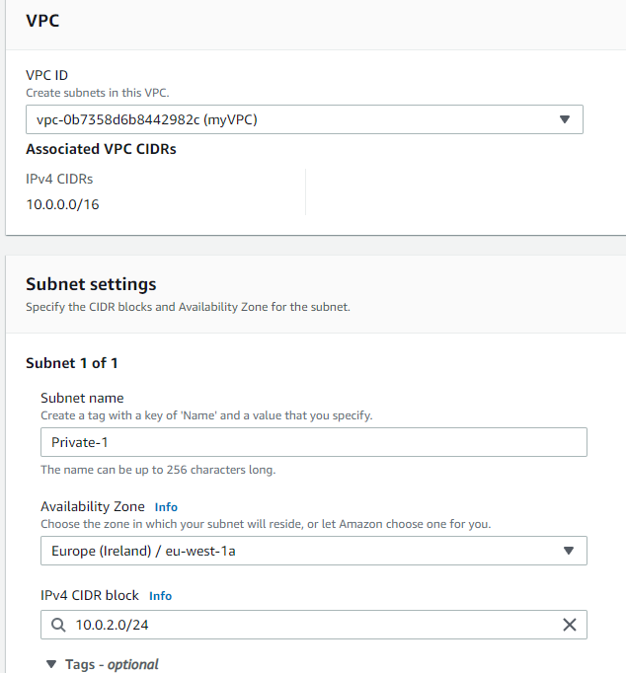

* Create IGW (Internet Gateway) & Attach to the VPC

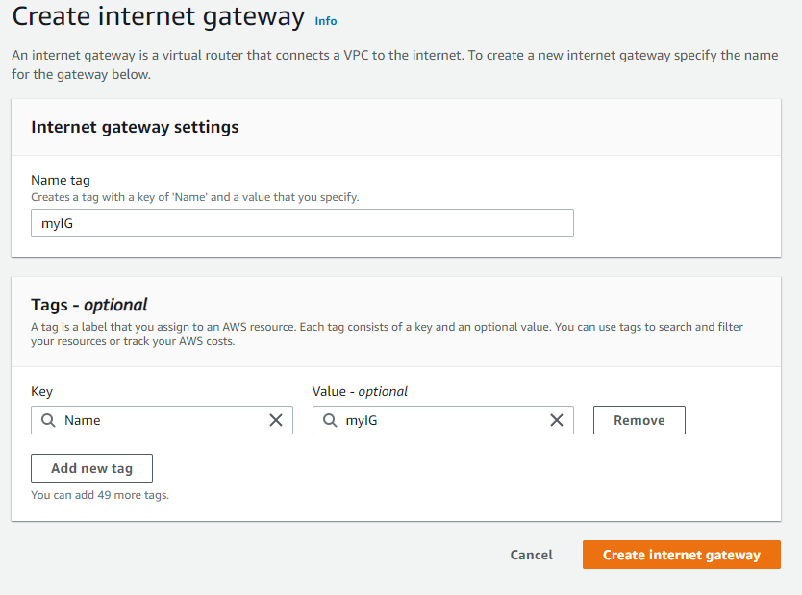

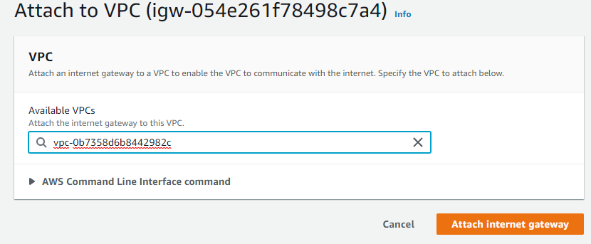

* Create Public and Private Route Table
  + under Route Tables select Public Route table(newRT)
  + 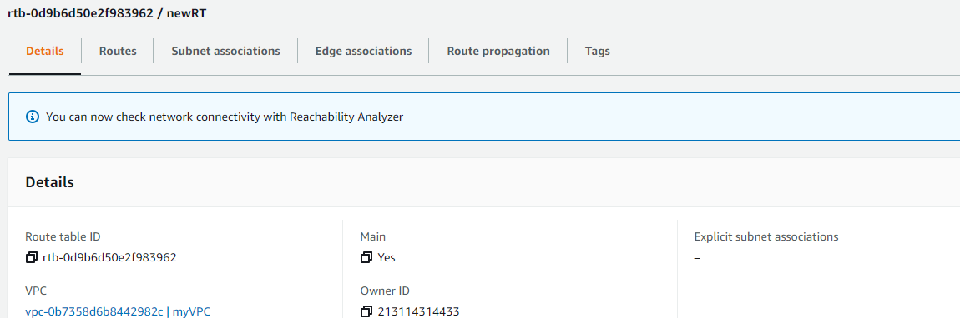
  + here, select Subnet associations
    - edit subnet associations
    - Add Public-1 subnet
    - 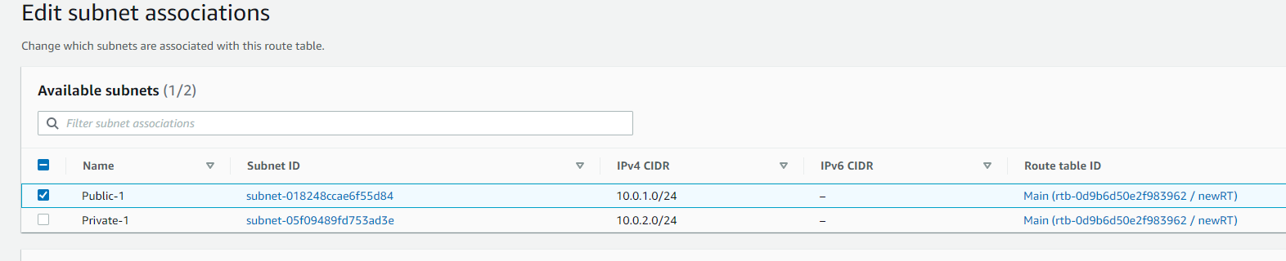
  + under newRT;
    - select Routes
    - edit routes
      * Add IGW in Public Route table (0.0.0.0/0)
      * 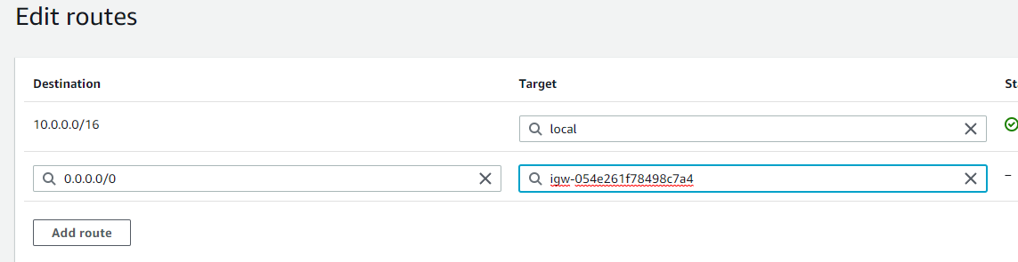
* Create new private Route Table-newprivateRT
  + 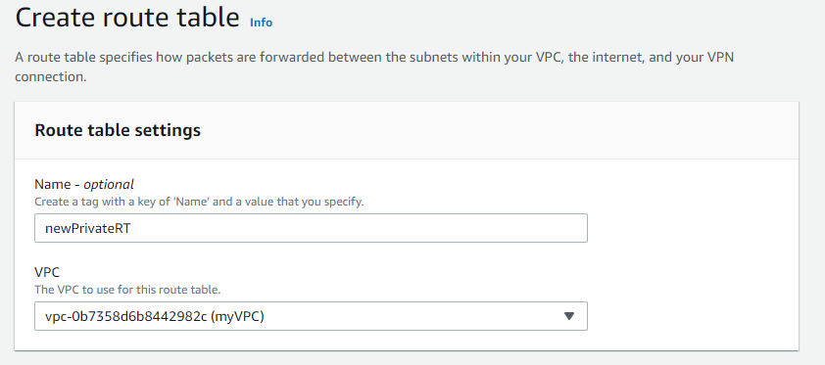
  + 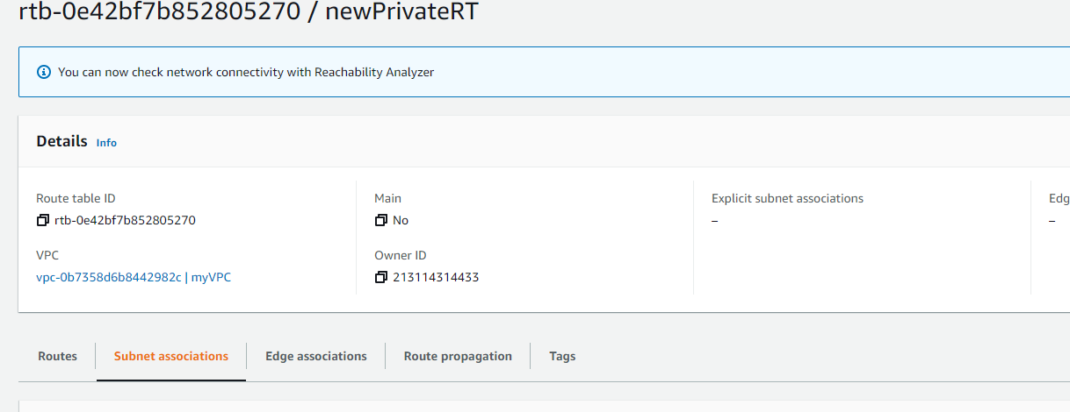
* Edit subnet associations
  + - add Private Subnet in Private Route Table
    - 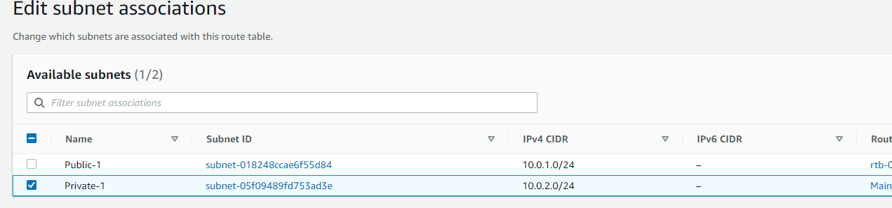
* Under myVPC create new security group

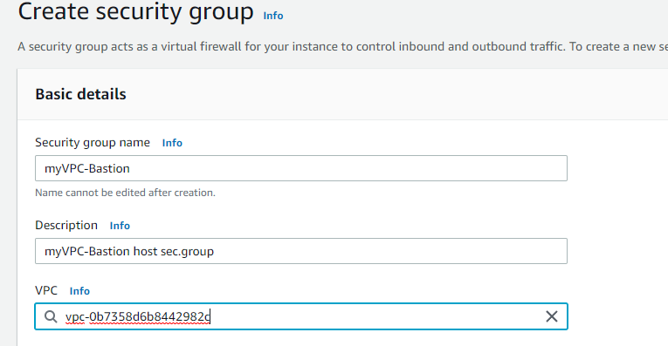

* Edit inbound rules
* 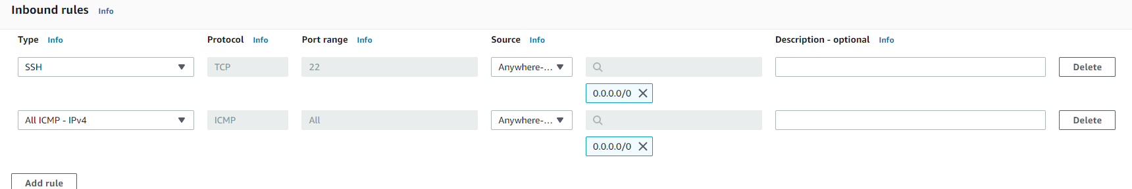
* Launch EC2 in this VPC - public Subnet with setting seen below:
  + AMI: Amazon Linux 2
  + Instance Type : t2.micro
  + Region: eu-west-1a
  + VPC: myVPC
  + Subnet:Public-1
  + Key:myKey
  + Security Group: myVPC-Bastion
* Launch EC2 in this VPC - private Subnet with setting seen below:
  + AMI: Amazon Linux 2
  + Instance Type : t2.micro
  + Region: eu-west-1a
  + VPC: myVPC
  + Subnet:Private-1
  + Key:myKey
  + Security Group: myVPC-Bastion-Pr
* Connect to your instance in Public subnet with SSH.
  + open an SSH client in the folder which myKey.pem is stored.
  + run this command, if necessary, to ensure your key is not publicly viewable.  
     chmod 400 myKey.pem
  + connect to your instance
    - ssh -i "myKey.pem" ec2-user@publicIP
    - 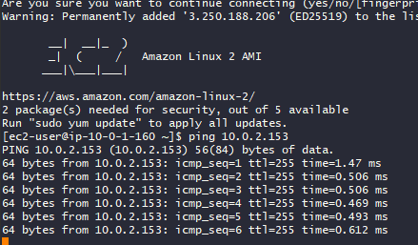
* here;
  + sudo su
  + nano myKey.pem
  + copy the inhalt of the myKEy.pem in nano
  + chmod 400 myKey.pem
  + ssh -i "myKey.pem" ec2-user@privateIP
* 